Course Code: CSA1557

Course Name: Cloud Computing and Big Data Analytics

M.Gowripriya

192224223

8) Create a simple cloud web application for student counselling system using any Cloud Service Provider to demonstrate SaaS with the fields of student name, age, address, phone, subjects studied, Year of passing, percentage of marks, domain interest, etc.

AIM: To Create a simple cloud web application for student counselling system using any Cloud Service Provider to demonstrate SaaS.

PROCEDURE:

step1: Go to zoho.com.

step 2: Log into the zoho.com.

step 3: Select one application step.

step4: Enter application name as library book reservation system.

step 5: Created new application as library book reservation system.

step 6: Select one form

step 7: The software has been created.

IMPLEMENTATION:

STEP1: GOTO ZOHO.COM

STEP 2: LOGIN TO THE ZOHO.COM

STEP 3: SELECT ONE APPLICATION

STEP 4: ENTER APPLICATION NAME

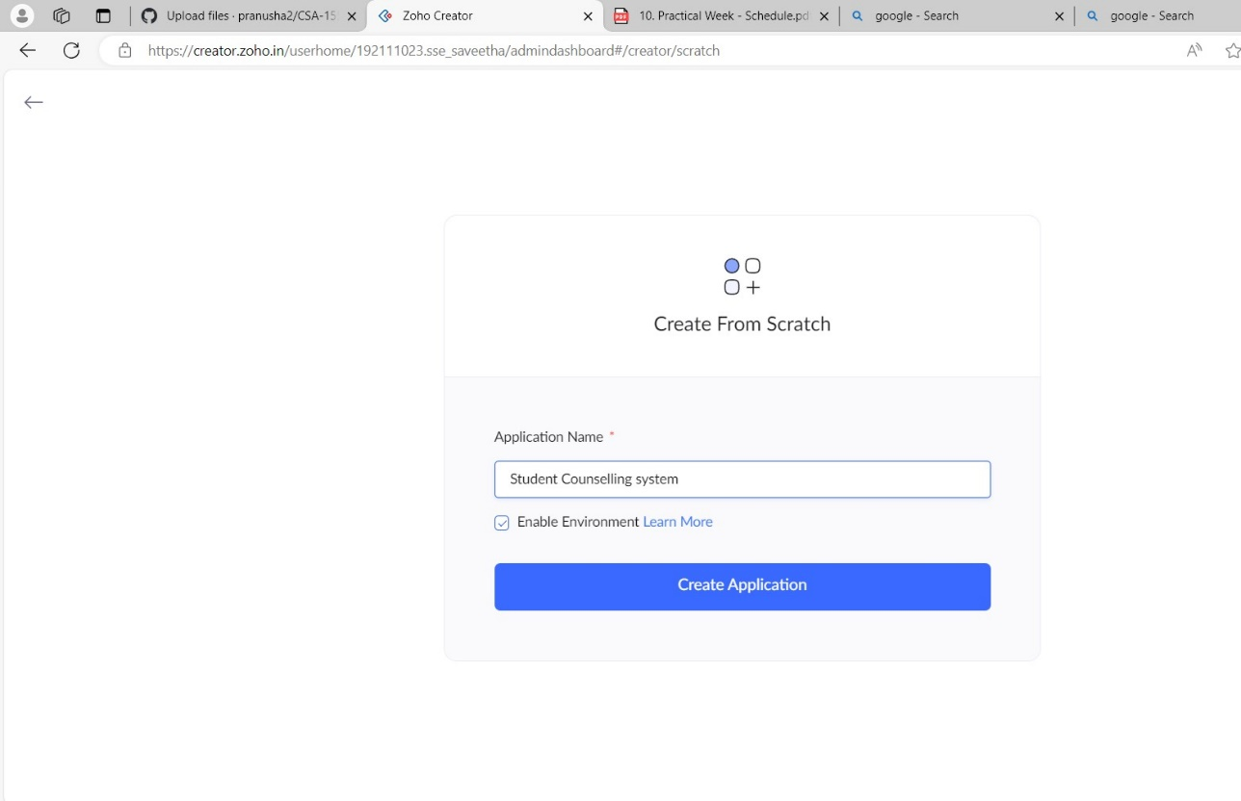

STEP 5: CREATED NEW APPLICATION

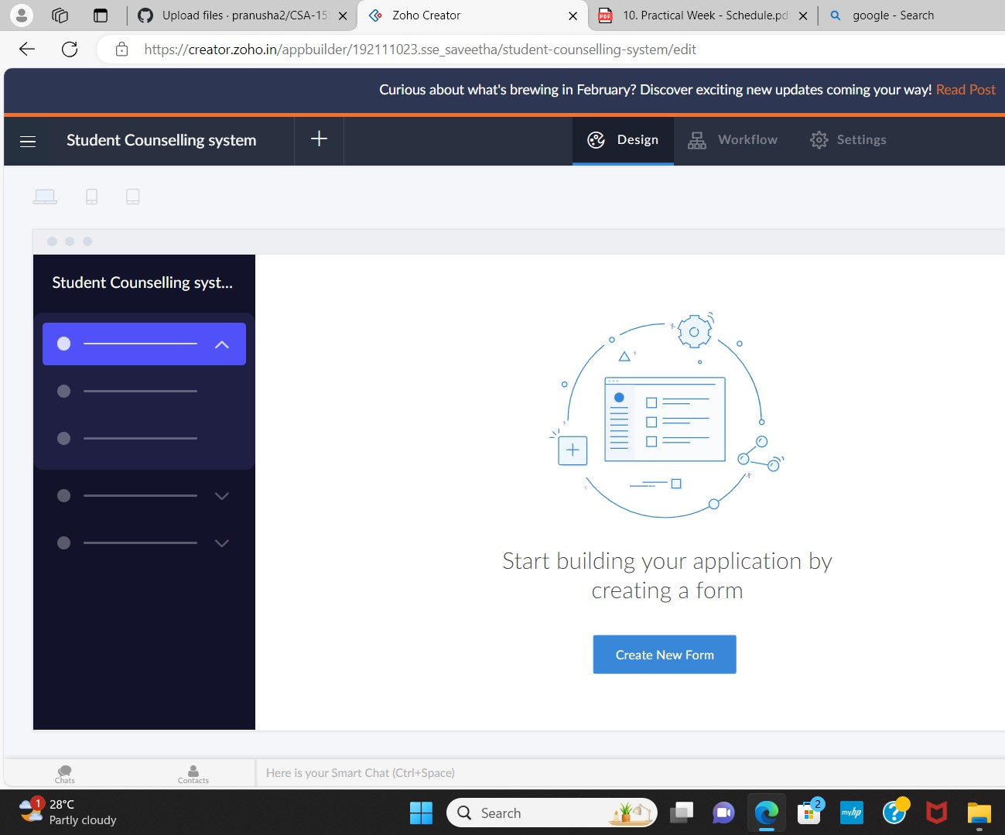

STEP 6: Select from Stratch and Create form as login.

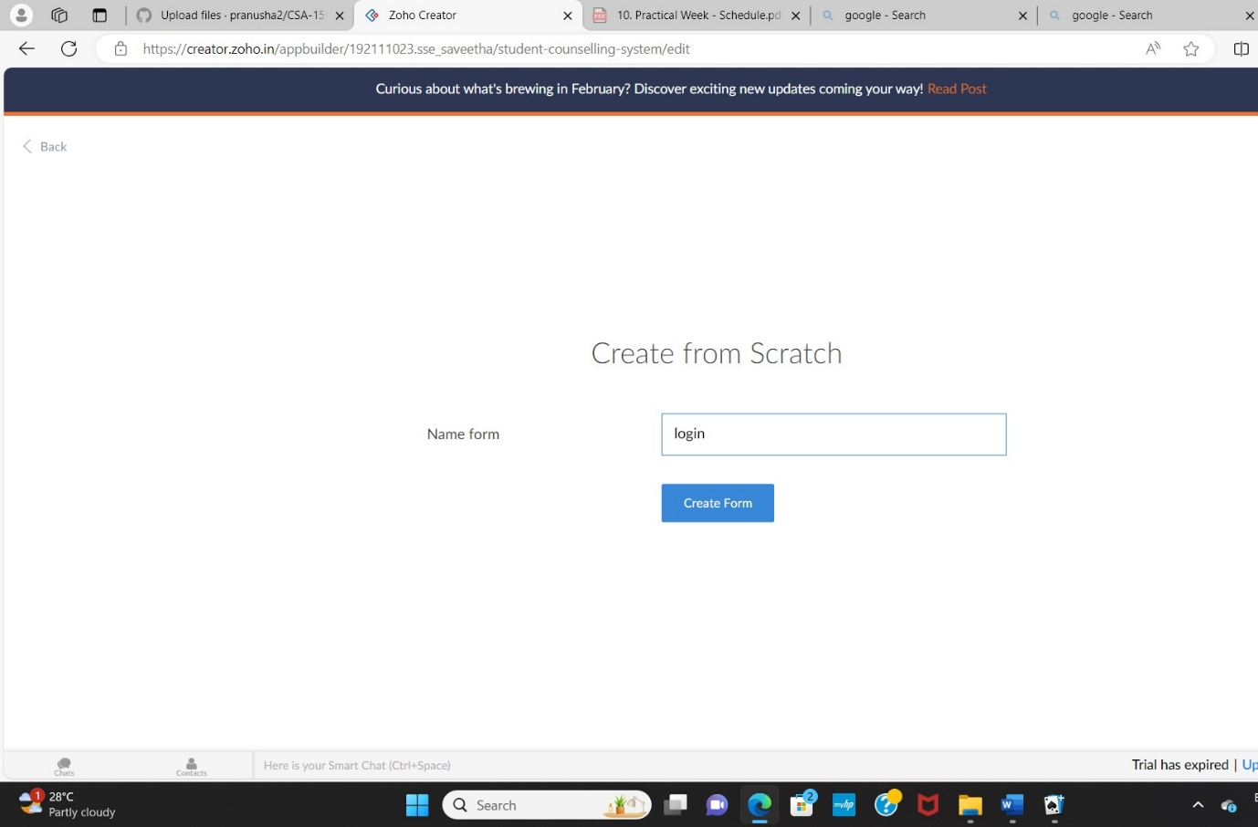

STEP 7: The form has been created as login.

Choose the fields.

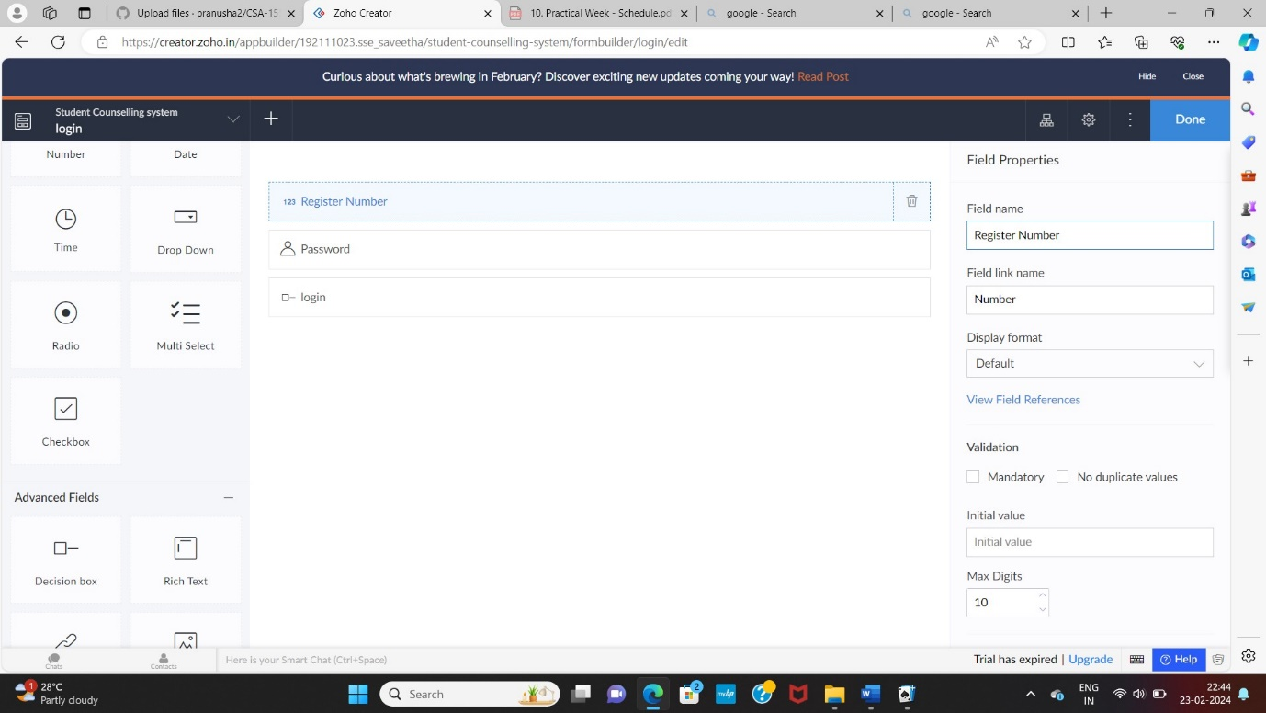

STEP 8: Click Access Development Live and enter the details to access.

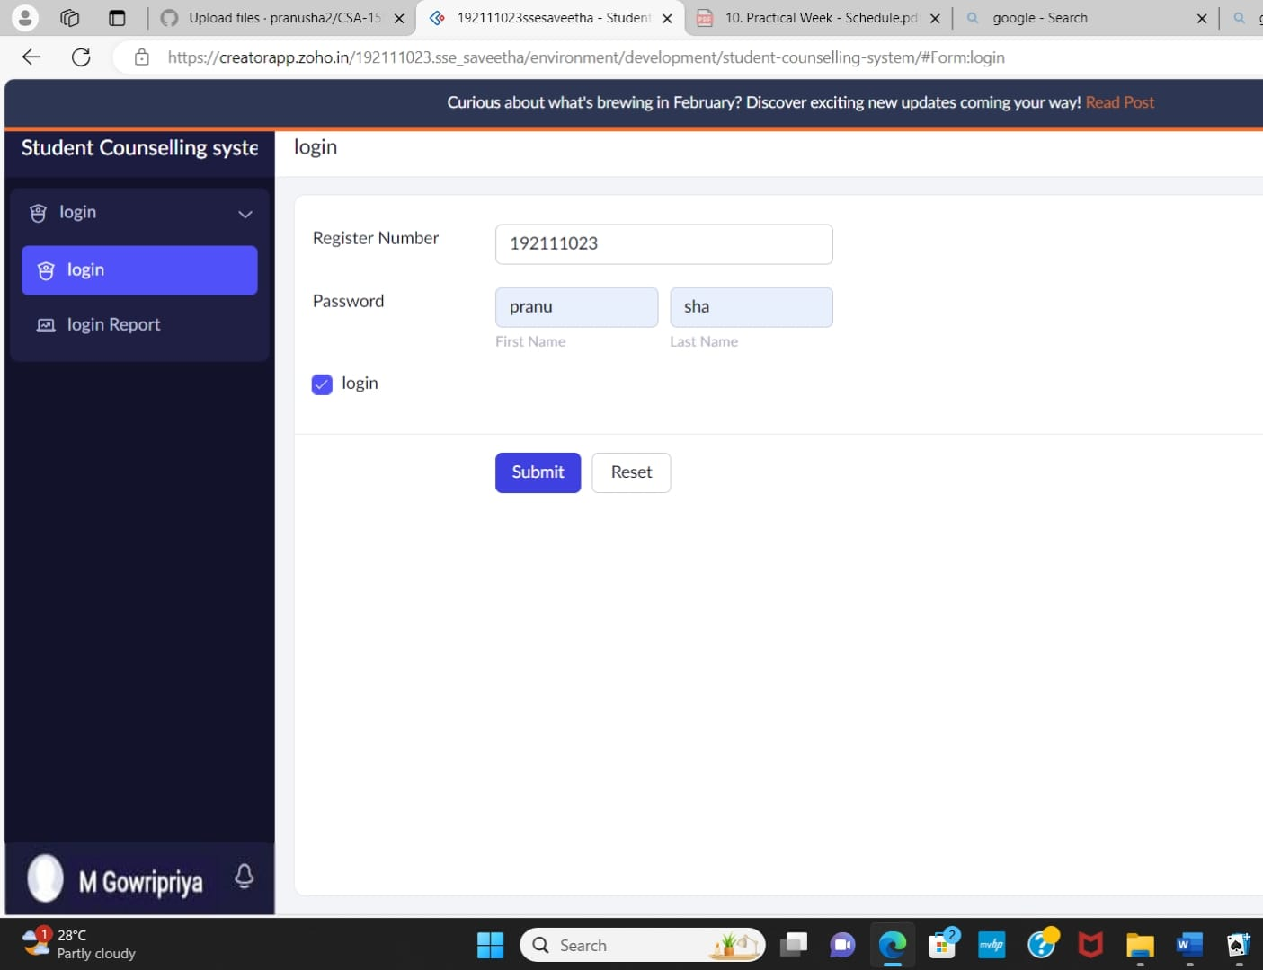

STEP 9: The report has been registered in the login report.

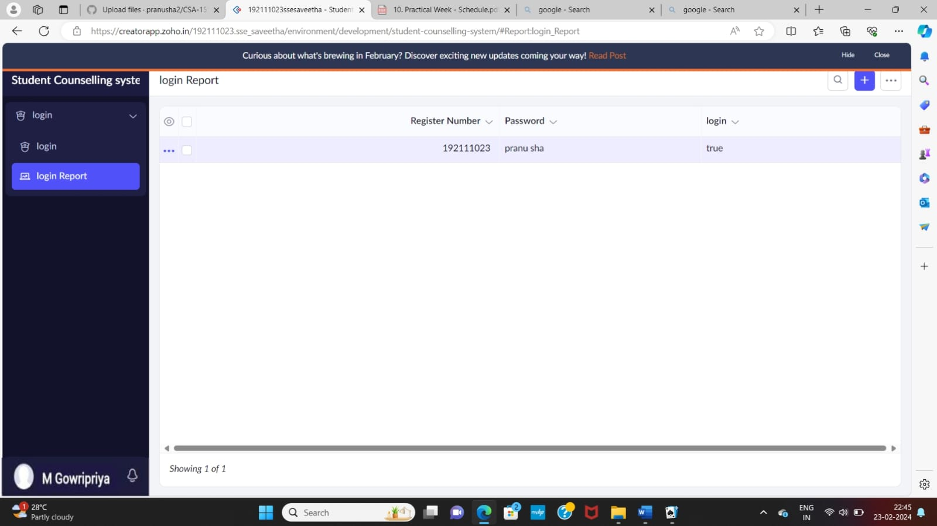

STEP 6: Select from Stratch and Create form as SIMATS.

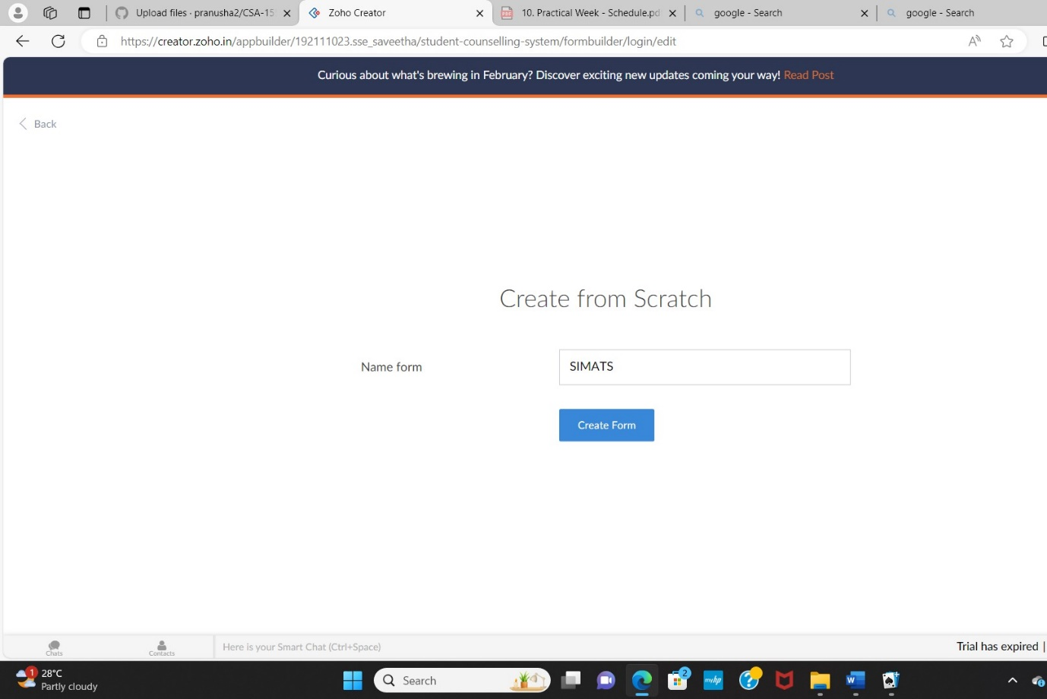

STEP 7: The form has been created as SIMATS.

Choose the fields.

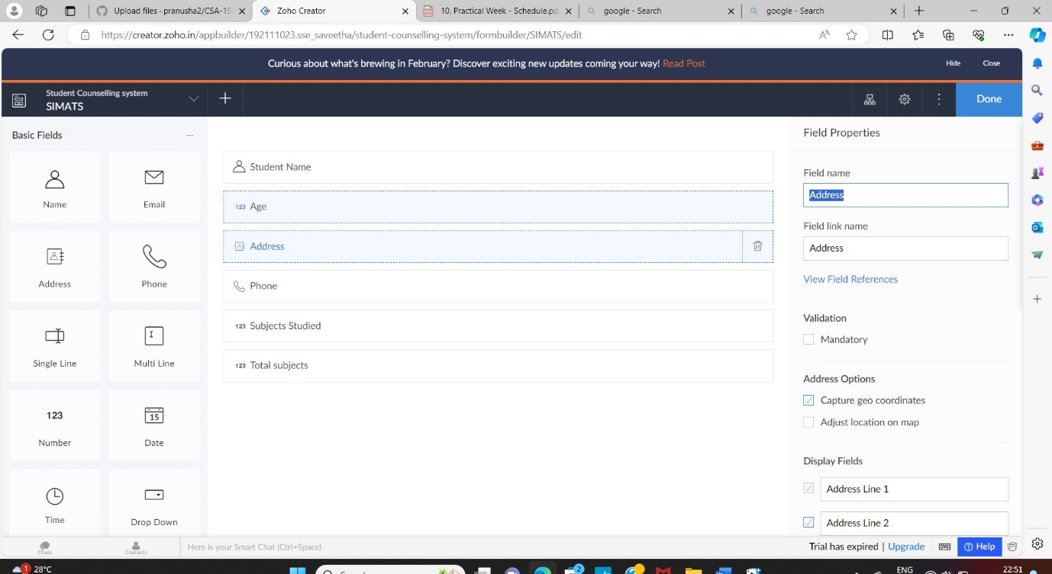

STEP 8: Click Access Development Live and enter the details to access.

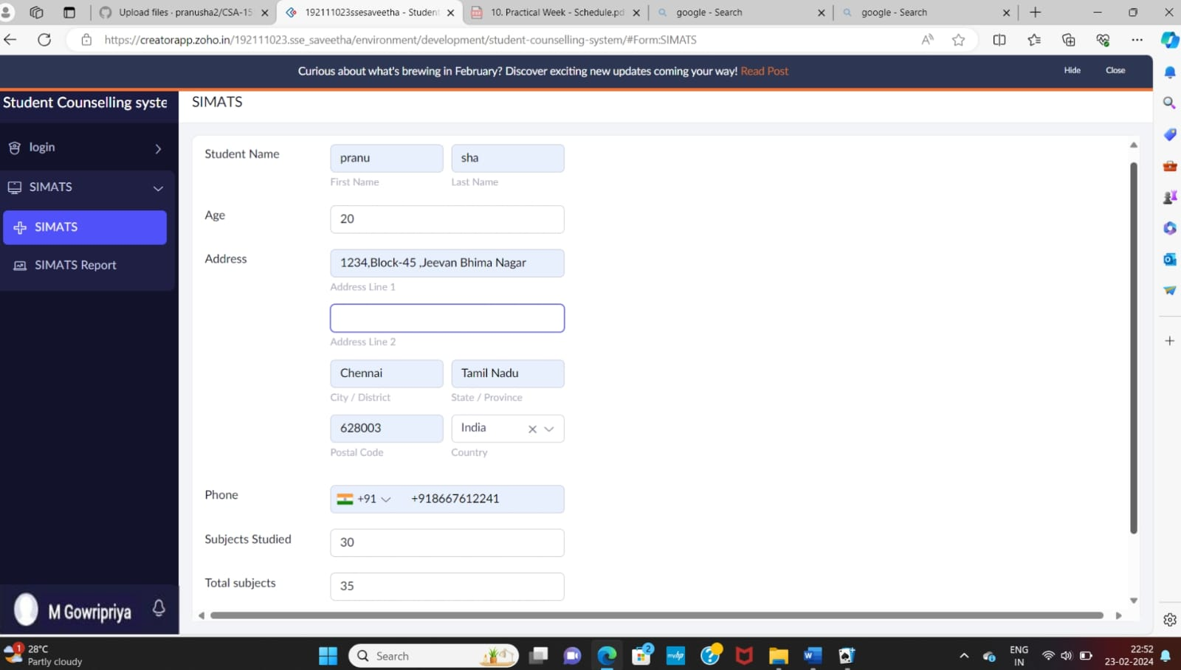

STEP 9: The report has been registered in the SIMATS report.

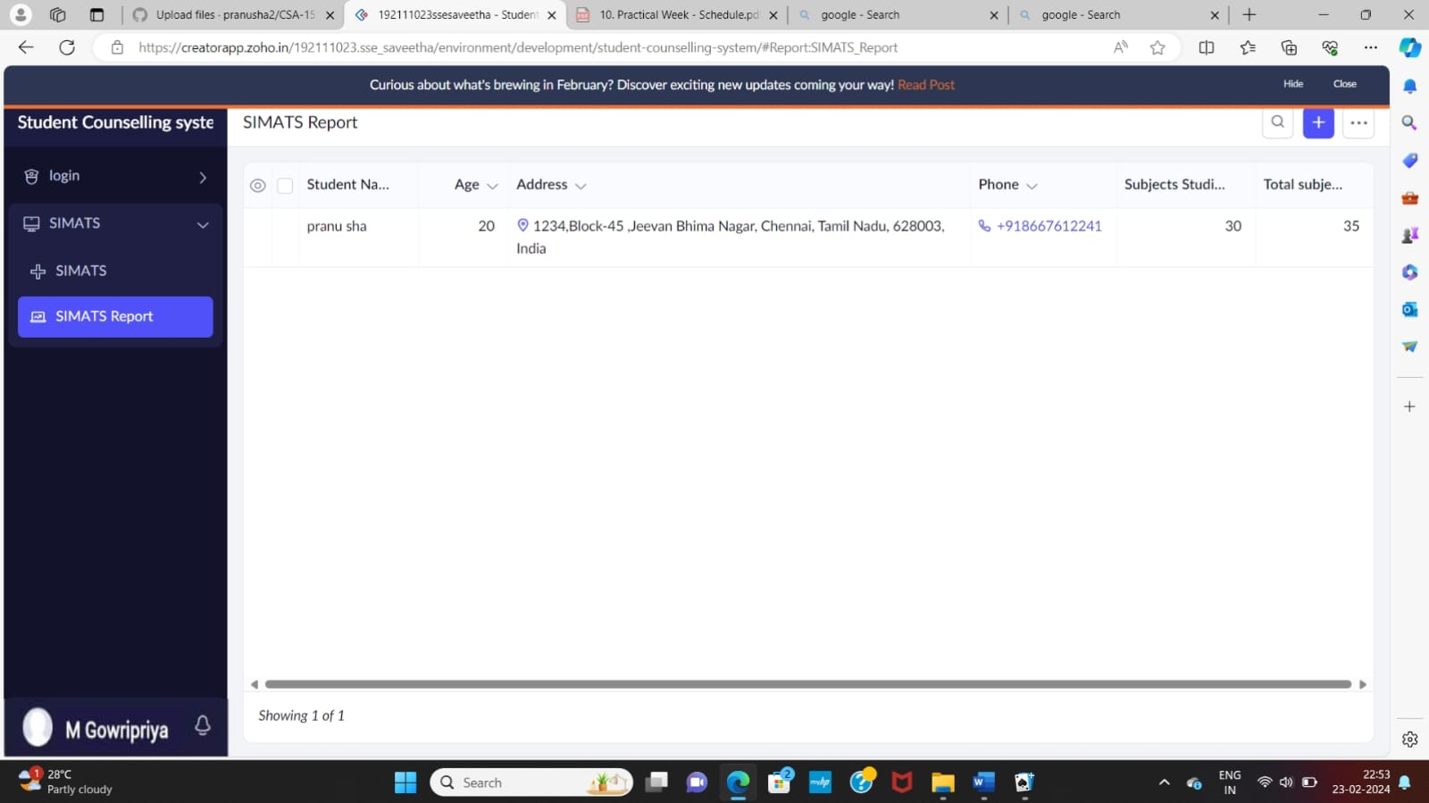

STEP 6: Select from Stratch and Create form as student details.

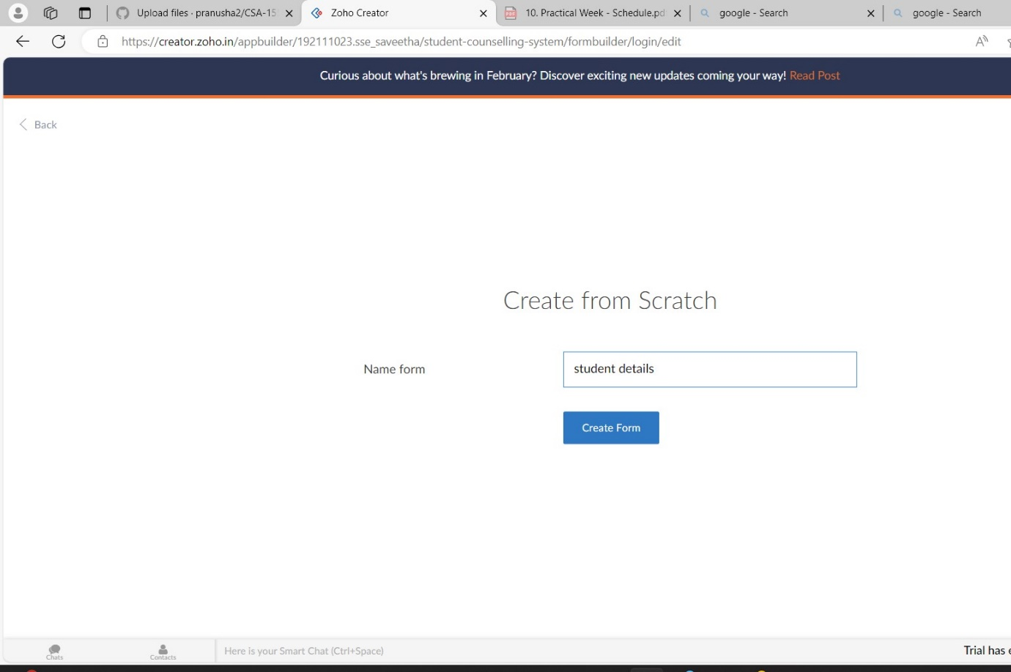

STEP 7: The form has been created as student details.

Choose the fields.

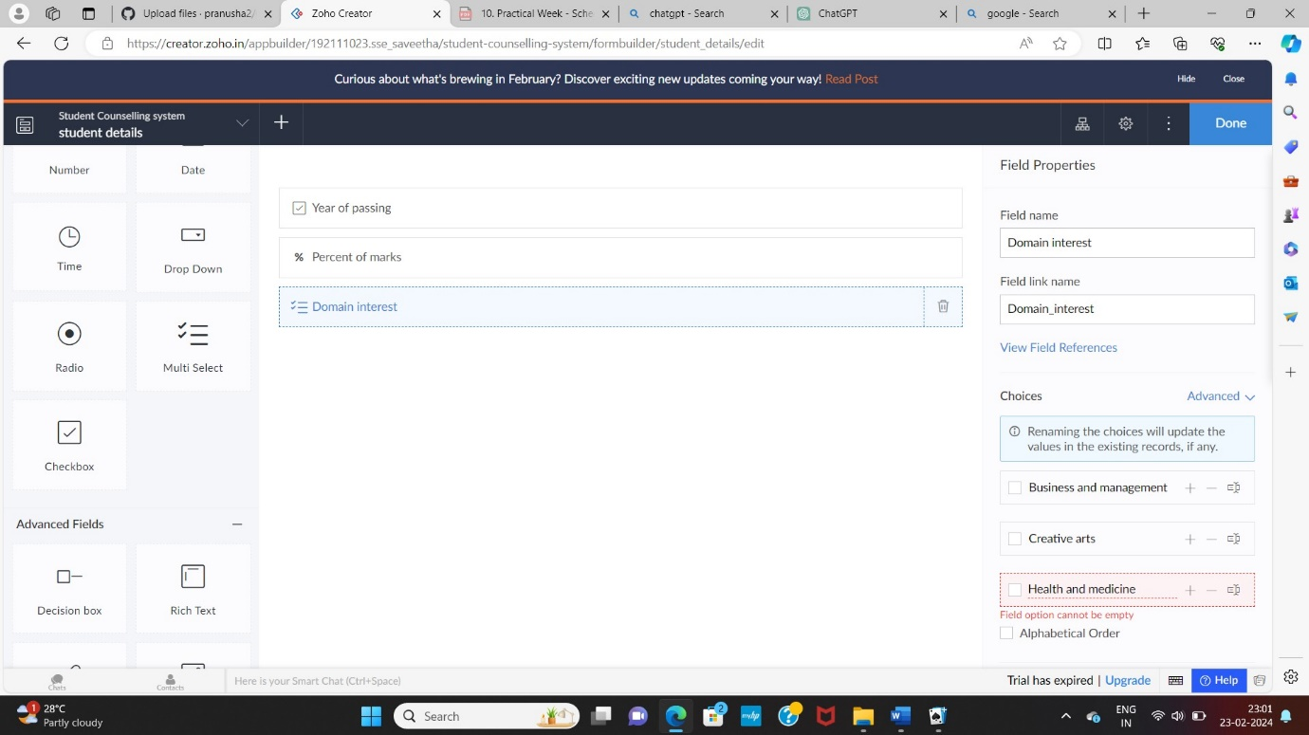

STEP 8: Click Access Development Live and enter the details to access.

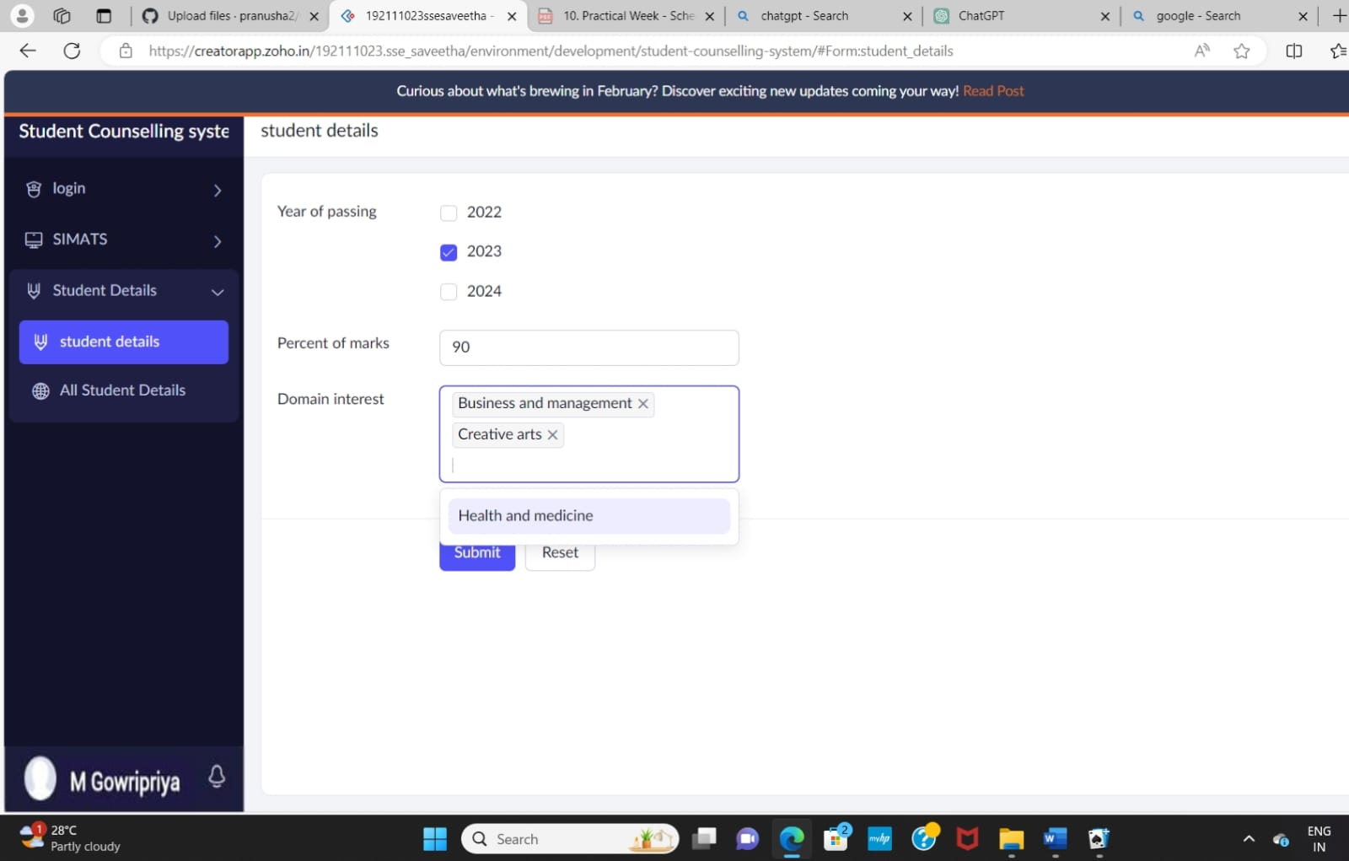

STEP 9: The report has been registered in the student details report.

